Art for the Internet
  - Blog
  - Projects
  - People

  - About

How to make a small holographic theater

December 06, 2010
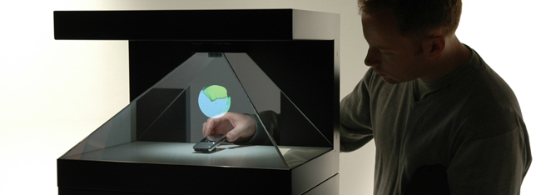
This holography display case is made by Realfiction. They use simple reflecting method to create a holography image between physical and virtual space. It looks amazing and it can be surprisingly new visual experience. Here is the link to Realfiction. It is easy to build your own holography case.
MATERIALS
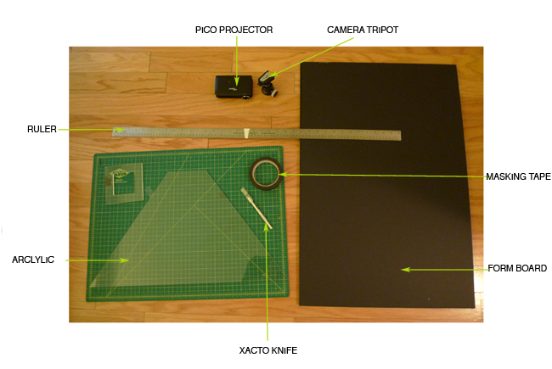
Arclylic , Xacto knife, Form board, Masking tape, Ruler, pico projector, camera tripot head
METHOLDOLOGY
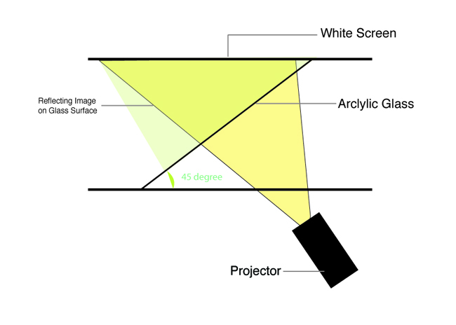
The projector can project image with a black background. The image will emerge from the bottom. The image will reflect on the acrlylic glass which is directed at a 45 degree angle between the stage and the white screen. The image will float up on the air like an illusion.
STEPS
Step1
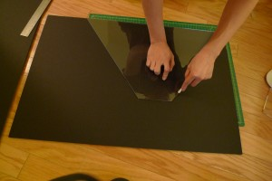
Cut the 2 black boards to the same size as the acrlylic glass.
Step2
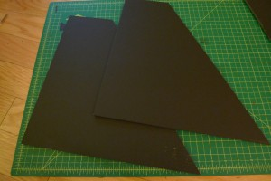
Cut the one side of the boards to the same size as the picture.
Step3
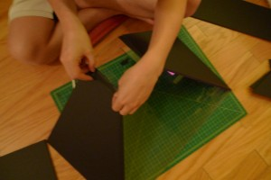
Attach the black board oneach side of the acrlylic glass to stand on the floor.
Step4
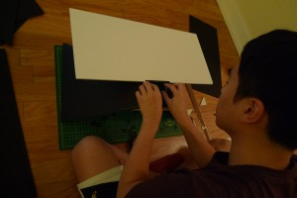
Attach a white foam board for the screen on the top of structure.
Step5
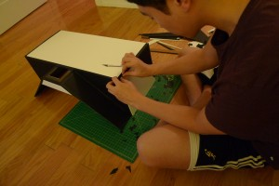
Cover the light around the acrylic glass.
Step 6
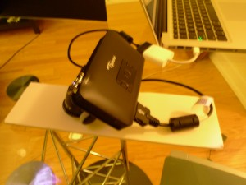
Connect the Pico projector to the head of tripod. and put bottom of hologram structure.
Step 7
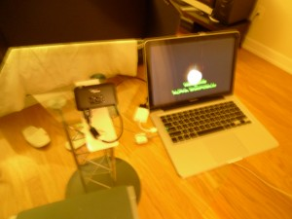
Connect VGA line with the computer.
Step8
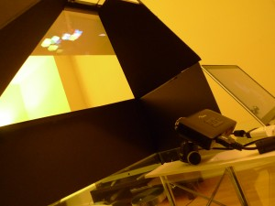
Lean the projector at a 45 degree, and it will project an image on the white screen.
For a more vivid holographic, the image should have a black background.
Step 9
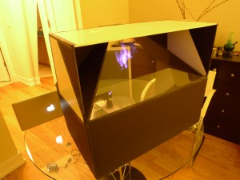
Now sit in front of the hologram theater, and enjoy the show ~!!
TEST
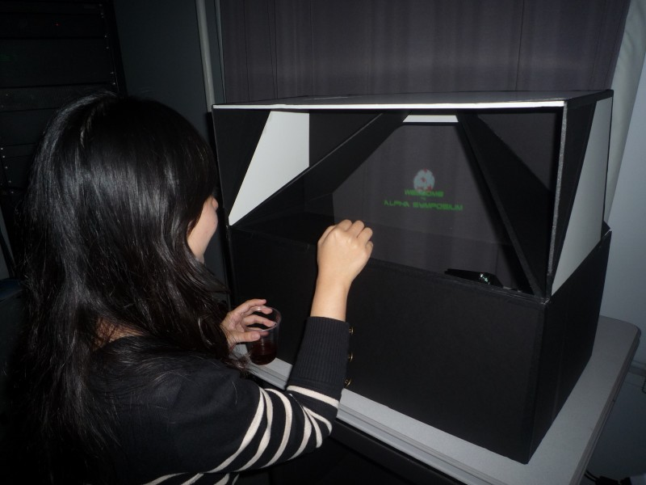
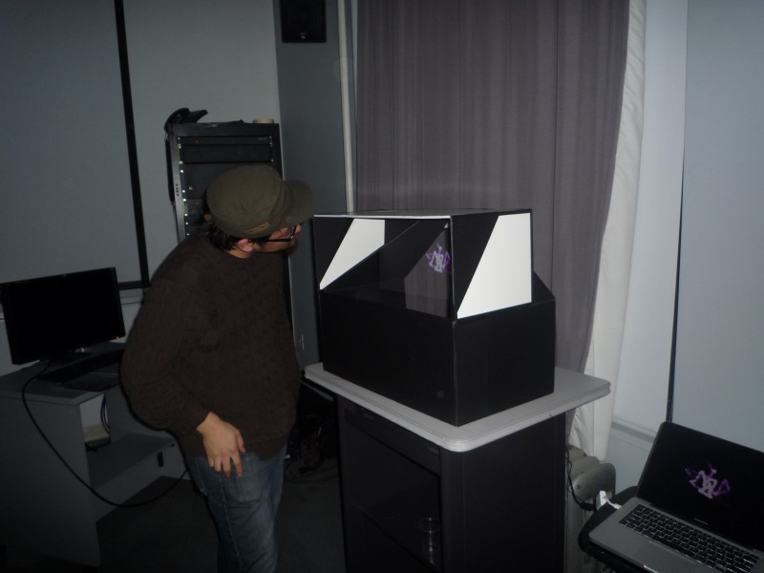

Share and Enjoy:

Posted by nayong6843 | Blog, Projects | | | Comments (7)

7 Responses to “How to make a small holographic theater”
- pigen says:
October 14, 2011 at 9:51 pm
COOL~!
Reply
- chima says:
May 25, 2012 at 1:02 am
cool stuff, but i need the measurement for the material used and the principles behind it pls.
Reply
- Brittany says:
January 23, 2013 at 8:28 pm
Thank you for the ideas. :)
Reply
- mostafa says:
April 8, 2013 at 5:58 pm
imaginative O_O (Y)
Reply
- mostafa says:
April 8, 2013 at 6:41 pm
i will try to make it
Reply
- taymur iqbal says:
May 27, 2013 at 11:25 am
i will try it
Reply
- Parth says:
September 25, 2013 at 4:22 pm
does the Refractive index and the thickness of the acrylic glass make a difference?
Reply

Leave a Reply

Name (required)
Mail (will not be published) (required)
Website

•

•
December 2010
M | T | W | T | F | S | S
« Nov
 |  | 1 | 2 | 3 | 4 | 5
6 | 7 | 8 | 9 | 10 | 11 | 12
13 | 14 | 15 | 16 | 17 | 18 | 19
20 | 21 | 22 | 23 | 24 | 25 | 26
27 | 28 | 29 | 30 | 31

• ARCHIVES
- December 2010
- November 2010
- October 2010
- September 2010
- August 2010

• META
- Log in
- Entries RSS
- Comments RSS
- WordPress.org

